SAGUI
Test Plan
For
SYS009597

User Group Enable / Disable

Prepared by: Shawn Khosravani
X8345

Introduction 3
Problem 3
Test Procedure 3

Introduction
This document contains test plans for a bug fix to SAGUI as part of 8.7 release.

Problem
In 8.6 release of SAGUI, a null pointer exception is thrown when attempting to Enable or Disable a groupof users through the User Group Management screen.

Test Procedure
- Start SA GUI and open the User Group Management screen from the Start menu. Select the Users tab if not already selected.
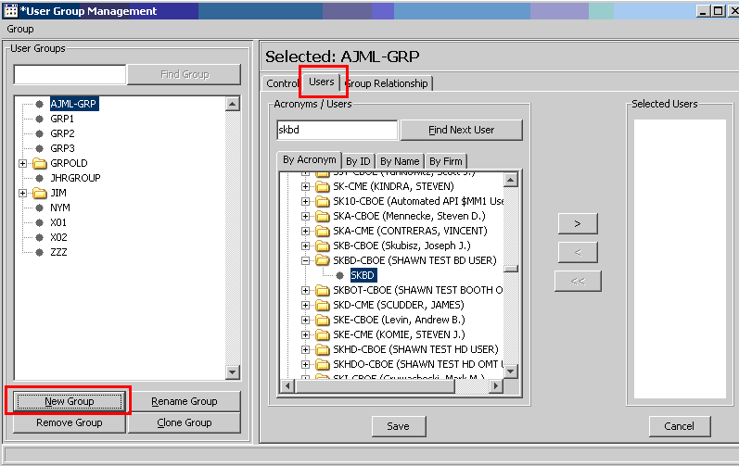

- Create a test user group and add a few users to the group. Don’t select any group or if you have, deselect it with the control key pressed (i.e. contorl + mouse click).
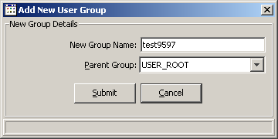

- Now add a few users to the group and save:
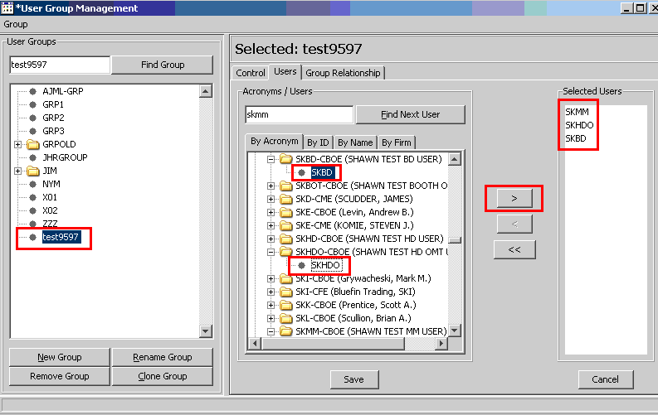

- Switch to the Control tab.
- Check the Disable box, which also selects Foce Logout , then click Go.
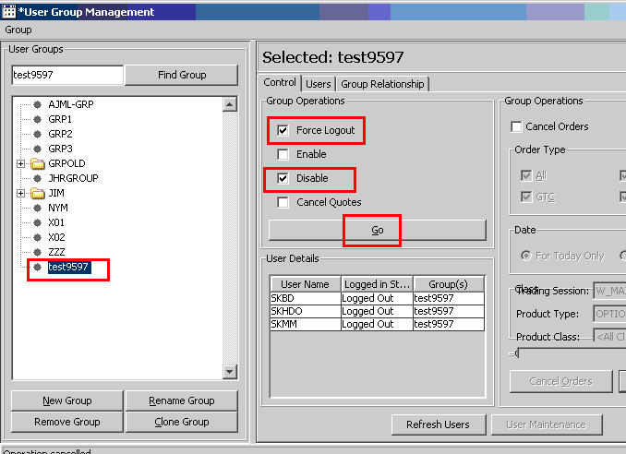
- In the confirmation screen select Accept and type YES in the text field, then hit Enter key. Finally click Submit twice
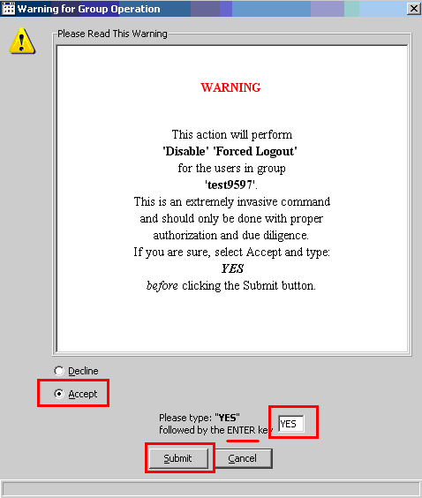
- Verify that no exception is displayed on the screen.
- Open the User Management screen from the Start button. Find the disabled users and verify that they are disabled:
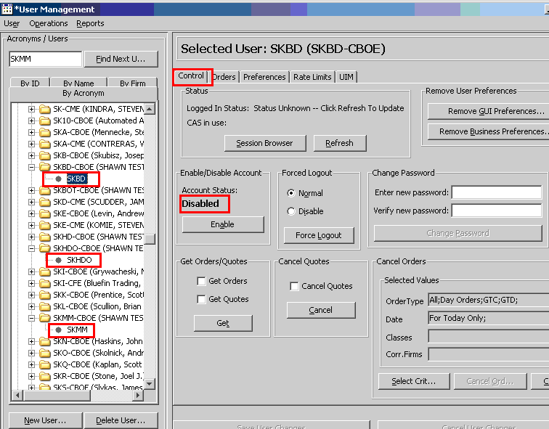
- Use the Trader GUI to log into the same environment using one or all of the disabled user IDs.
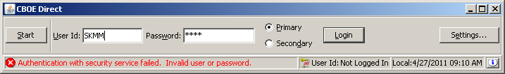
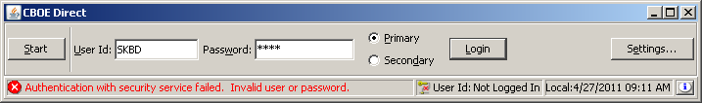
- Go back to the User Group Management and select the same group. This time check the Enable box and click Go. Do the same confirm steps and Submit:
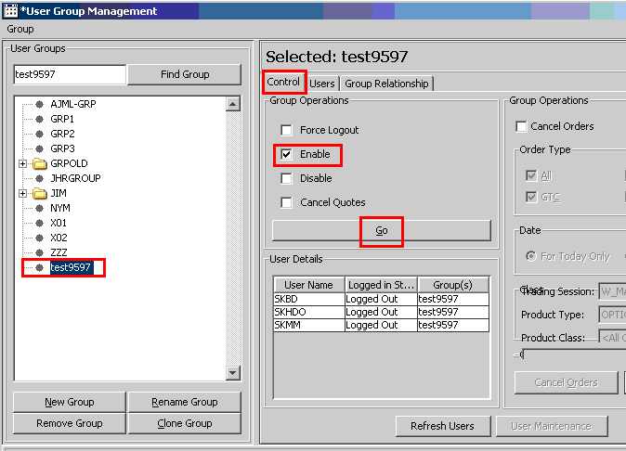
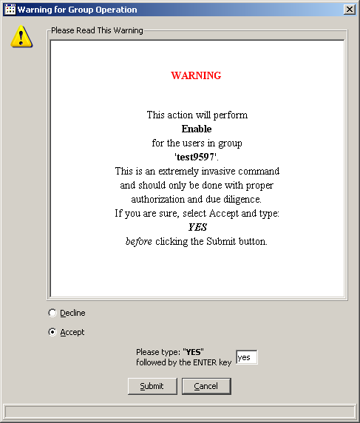
- Again verify that no exception was shown on the display.
- Go back to the User Management screen and verify that the users are Enabled again:
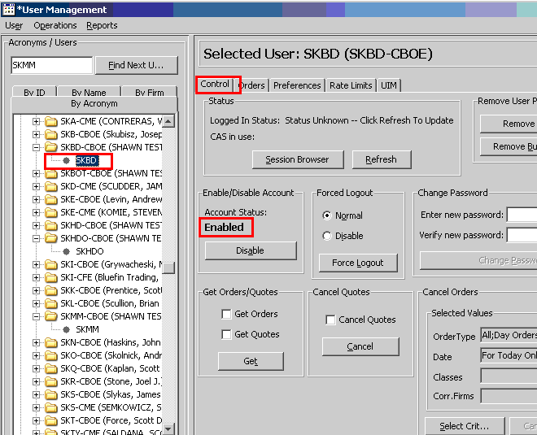
- Again use the Trader GUI and verify that the enabled user(s) can now log into the same environment:

